

Time Study in Butaro Level II Teaching Hospital Outpatient Department
By
Rwema Ivan Steve

Submitted in Partial Fulfillment of the Requirements for the
Master of Science degree of Global Health Equity
University of Global Health Equity
Capstone Practicum

Organization: University of Global Health Equity
Preceptor: Butaro Level II Teaching Hospital.
Date: 10/7/2025

DECLARATION

I, Rwema Ivan Steve, hereby declare that the practicum capstone thesis has been written by me without any external unauthorized help, that it has been neither presented to any institution for evaluation nor previously published in its entirety or in parts. Any parts, words or ideas, of the thesis, however limited, which are quoted from or based on other sources, have been acknowledged as such without exception.

Signature:  Date: 7/10/25

Dedication
To God For the wisdom, strength, and grace to complete this work.
May this effort reflect His purpose through me.

Acknowledgement

I am deeply grateful to my academic advisors, Dr. Rex Wong and Mr. Prince Murindwa, for their invaluable guidance and support throughout this journey.

Special thanks to the team at Butaro Level II Teaching Hospital for their collaboration and insight.

I extend heartfelt appreciation to my family and friends; your prayers, encouragement, and belief in me made this possible. I thank Nshimiyimana Etienne, Mukamana Eugenie, Christine Ashimwe, Ntwali Kenny Bivegete, Viviane France, Emmanuel Byakagaba, Nathalie Uwamwezi, Florence, Eric Niyitanga, Olive, and the entire UGHE community at large for standing with me through every step.

This capstone reflects many hands and hearts. Thank you all.

Abstract

Background
Long waiting times in outpatient departments (OPDs) are a persistent challenge in low and middle-income countries, especially in rural settings where staff shortages, poor coordination, and high patient volumes affect care quality. Waiting time refers to the period a patient spends between arriving at a service point and receiving care. Long waits contribute to overcrowding, patient frustration, and delayed treatment. In Rwanda, little is known about the status of waiting time in rural facilities like Butaro Level II Teaching Hospital and the factors associated with long patient waiting time.

Objective
This study aimed to measure waiting and process times for outpatients at Butaro’s OPD, identify the main causes of delay, and propose simple, practical solutions to improve patient flow.

Methods
A cross-sectional observation study (time-motion) was conducted over four weeks, tracking 131 patients from arrival to exit from 6:30 AM to 5:00 PM. Observers recorded the time spent at each service station, along with notes on congestion, staffing levels, and operational challenges such as unclear signage or patient confusion.

Results
Patients spent a median of 264 minutes at the OPD, of which 94% was waiting time. The longest waits were at radiography (118 minutes) and consultation (93 minutes), and the shortest waiting times were observed at the laboratory (17 minutes). Nearly half (48.9%) of patients dropped out after registration, mostly because they were non-OPD patients using the same intake points, which created unnecessary congestion. Afternoon patients spent significantly less time compared to morning patients in the OPD (p = 0.0031), largely because even though services started at 8:00 AM, on average, 29 patients were there before 6:30, and this large crowd before services opened contributed to early morning crowding and naturally longer waiting times.

Patient volumes also regularly exceeded the OPD’s consultation capacity of 80 per day. As a result, some patients had to return the next day, creating a daily backlog that built up over the week. Staff-related issues were also common: observers recorded 16 instances of staff stepping away, especially during lunch hours, and several departments started services later than the official opening time.
In addition, we observed limited patient navigation support: there was no clear signage, no help desk, and no structured queue system. This led to confusion, patients going to the wrong stations, being overtaken in line, or waiting unnecessarily.

Conclusion
This study highlights the urgent need to streamline outpatient care in rural hospitals. Key solutions include separating intake at registration for different patient types, numbering chairs to manage queues, scheduling return visits properly, adjusting staff levels to match demand, and improving signage and patient guidance. These low-cost changes can reduce waiting times and improve the care experience in rural health systems.

Table of Contents
1. Introduction 1
2. Literature Review 3
2.1. Quality Health Care 3
2.2. Waiting time in healthcare 3
2.3. Waiting time in the Outpatient Department (OPD) 3
2.4. Impacts of long waiting times 4
2.5. Common factors causing long waiting times 4
2.6. Interventions aimed at reducing waiting times 5
2.7. Wait time in Rwanda 6
3. METHODS 7
3.1. Study Setting 7
3.2. Typical workflow in the outpatient department 7
3.3. Study Design 9
3.4. Study population and sample 9
3.4. Sampling Strategy 9
3.5. Data Collection Procedure 9
3.6. Data Collection Tool 10
3.7. Key Measures 10
3.8. Data collector training 10
3.9. Data Management 10
3.10. Data Analysis 10
4. RESULTS 12
5. Discussion 18
6. Conclusion 24
7. References 25
8.Appendices 29
Appendix A 29
Appendix B 30
Appendix C 31

List of Tables
Table 1. Summary of Process Times by Station 12
Table 2. Median Wait Times and Process Time by Station 12
Table 3. Overall Time Spent in hospital by day of the week and time. 13
Table 4. Station Wait Times by Time of Arrival (AM vs PM) 13
Table 5. Observed events potentially causing delay 14
Table 6. Number of Patients Exiting OPD Flow After Registration 15
Table 7. Daily consultation load and carryovers 16

List of Figures

Figure 1. Patient Journey at the OPD 8
Figure 2. Patients observed waiting at 6:30 AM 14
Figure 3. Number of Patients Sent to Radiography Before and After 12 PM 15
Figure 4. Number of Patients Exiting OPD Flow After Registration (by Day of the Week) 16
Figure 5. Daily consultation load and carryovers 17

List of Abbreviations

OPD | Outpatient Department
HICs | High-Income Countries
LMICs | Low- and Middle-Income Countries
IOM | Institute of Medicine
BL2TH | Butaro Level II Teaching Hospital
PIH | Partners In Health
UGHE | University of Global Health Equity
IRB | Institutional Review Board
SPSS | Statistical Package for the Social Sciences
NCD | Non-Communicable Diseases
IRV | Infectious and Respiratory Diseases

1. Introduction
Waiting time is generally referred to as the time a patient spends from entering a healthcare facility to receiving the required service (McIntyre & Chow, 2020). Long waiting times in outpatient departments (OPDs) remain a persistent challenge across low- and middle-income countries, where resource constraints, administrative inefficiencies, and growing patient loads often converge to undermine timely access to care. These delays contribute not only to overcrowding and diminished patient satisfaction but also to adverse health outcomes and increased financial burdens for patients and health systems alike. In Rwanda, research on waiting times has focused on urban or tertiary hospitals, leaving a critical gap in understanding the operational realities of rural facilities. Butaro Level II Teaching Hospital, a major referral center in Northern Rwanda, exemplifies this underexplored context. Despite its important role in serving a predominantly rural population, there is limited knowledge on the efficiency of its outpatient services and the patient experience within its OPD.
The significance of waiting time as a core indicator of healthcare quality is well established. The Institute of Medicine recommends that at least 90% of patients should be seen within 30 minutes of their scheduled appointment, yet studies in sub-Saharan Africa consistently report median waiting times ranging from 1.3 to four hours (Mohebbifar et al., 2013), far exceeding this benchmark. Prolonged waiting times are linked to increased patient dissatisfaction, higher rates of patients living without being seen, and even increased mortality for time-sensitive conditions. In addition to clinical risks, long wait times impose social and financial costs on patients, particularly in rural areas where travel distances are long and opportunities for income generation are limited. In Rwanda, studies have found that up to 71% of patients express dissatisfaction with consultation waiting times, and that both provider shortages and administrative bottlenecks are major contributors to these delays (Augustin, 2022).
The drivers of long waiting times are multifactorial, encompassing staff shortages, inefficient workflow, manual record-keeping, and inadequate patient guidance. Evidence from similar settings demonstrates that targeted interventions such as optimizing staff schedules, implementing structured queuing systems, improving signage, and introducing appointment-based follow-up can significantly reduce delays and improve both operational efficiency and patient satisfaction. However, there remains a scarcity of data on the specific challenges and potential solutions in rural Rwandan hospitals like Butaro.
This study addresses this critical gap by systematically tracking patient flow through the OPD at Butaro Level II Teaching Hospital, quantifying waiting and process times at each service point, and identifying the key factors contributing to delays. The research aims to develop actionable insights and propose context-appropriate, low-cost interventions to enhance service efficiency and patient experience. The findings will inform broader efforts to strengthen rural healthcare delivery in Rwanda and similar resource-constrained environments.
Research Questions:
- What is the median total time spent by patients at the OPD, and how is this time distributed between waiting and service delivery across the stations?
- What system-level and operational factors contribute to outpatient delays, and what targeted strategies could mitigate them?

Study Objectives:
- To measure the total patient median waiting time spent at OPD and how the waiting time is distributed across different delivery service points by June 2025.
- To identify the system-level and operational factors that contribute to service delivery delays at OPD.
- To propose context-appropriate interventions to reduce wait times by July 2025.

2. Literature Review

2.1. Quality Health Care
Quality healthcare is a fundamental right and a critical component of effective health systems globally (World Health Organization et al., 2018). It encompasses various dimensions, including safety, effectiveness, patient-centeredness, timeliness, efficiency, and equity (Alhur et al., 2022). Timeliness, which is often reflected in waiting times, is a direct measure of a system’s ability to deliver prompt care, operational effectiveness, overall patient experience, and satisfaction (Klundert et al., 2023). As disease burdens shift and populations grow, healthcare systems face increasing pressure to adapt while maintaining these standards (Lewis & Kruk, 2019).

2.2. Waiting time in healthcare
While the functional definitions of wait time in healthcare vary across regions and contexts, it is generally referred to as the time a patient spends from entering a healthcare facility to receiving the required service (McIntyre & Chow, 2020). More specifically, it is the length of time between enrolling a patient at the registration counter and the period that a patient takes at each point of service before being treated (Biya et al., 2022). Waiting time is a critical indicator of operational efficiency in the outpatient department (OPD) within hospital settings.

2.3. Waiting time in the Outpatient Department (OPD)
The OPD refers to the medical facilities that provide care to patients without admitting them into the hospital, excluding the Accident and Emergency (A&E) unit. It serves as a critical entry point for most hospital services and often experiences the longest queues and waiting times (Sharma et al., 2012). There is no universally agreed-upon standard OPD wait time, however, the Institute of Medicine (IOM) recommends that at least 90% of patients should be seen within 30 minutes of their scheduled appointments (Bs, 2020). The magnitude of wait times varies significantly across healthcare systems, with notable disparities between high-income countries (HICs) and low- and middle-income countries (LMICs).
In HICs, waiting time issues are generally less severe. A Study in the United States found that the average OPD waiting times ranged from 11.4 to 37.7 minutes across facilities (McIntyre & Chow, 2020). A similar median waiting time of 18 minutes was found in Australia. However, 10% of patients experienced significantly longer waits, up to 93 minutes (McIntyre & Chow, 2020).
In LMICs, waiting times typically range between 1.3 - four hours, with an overall average of 2.7 hours (Mohebbifar et al., 2013). This far exceeds the 30-minute standard recommended by the Institute of Medicine (IOM) (Bs, 2020). For instance, OPD waiting times at Mwananyamala Hospital in Dar es Salaam, Tanzania, had an average waiting time of 2.6 hours to five hours ( Msengwa, 2018.)
Regardless of the settings, long waiting times could have consequences extending beyond individuals’ satisfaction, impacting their health outcomes and safety.

2.4. Impacts of long waiting times
Research consistently shows that longer waiting times negatively impact patient satisfaction and trust in healthcare settings. Studies in South Africa and Nigeria showed that long waits eroded patient trust and led to frustration and negative perceptions of healthcare systems (Enabulele, 2018). Surveys in Nigeria found that patients perceived waiting for more than 30 minutes as excessive (Usman et al., 2020). Similar studies in Malaysia found an average waiting time of one to two hours in the outpatient department, and patients were significantly more dissatisfied when waiting for more than 30 minutes (Ab & Kn, 2017). Similarly, in Rwanda, 71% of patients expressed dissatisfaction with consultation waiting times (Augustin, 2022).
Patient satisfaction is not the only consequence, longer delays at various stages of care, from symptom onset to treatment, are associated with increased mortality rates and poorer functional outcomes for patients in need of time-sensitive treatments(Guttmann et al., 2011). Studies have found that about 3% to 10% of patients would leave the hospital without ever seeing a doctor out of frustration due to prolonged waiting time( Khanna et al., 1999; Guttmann et al., 2011)
Long wait times have been linked to a potential 30% increase in risk of death for patients who had to wait up to 10 days for care. Additionally, those who left without receiving treatment faced adverse effects, as they remained untreated and vulnerable to their illness (Guttmann et al., 2011). A study on hip fracture patients showed that the 30-day mortality risk increased from 5.8% for earlier surgery to 6.5% if delayed for more than 24 hours (Pincus et al., 2017).
The risks extend beyond clinical concerns. In Gauteng Province, South Africa, patients arrive at health centers as early as 3 a.m. to secure a place in line, even though services begin at 9 a.m. (Makua & Khunou, 2022). Nurses from these health centers warned that these practices raised serious safety concerns, exposing patients to criminal activity, adverse weather, and health complications due to prolonged waiting (Makua & Khunou, 2022).
Long wait times also have a significant financial impact on patients. A study found that each one-hour delay increases hospital costs by 30% for critical patients and 21% for moderately acute cases, leading to higher medical expenses (Woodworth & Holmes, 2020).
Given these widespread consequences, it is essential to examine the underlying factors driving long waiting times. Waiting time remains a significant concern, with causes related to resource constraints, systemic challenges, and unethical behavior by doctors.

2.5. Common factors causing long waiting times
Long waiting times in the OPD typically result from a shortage of healthcare providers. This imbalance in staff to patient is highlighted in a study in Iran, where patients would spend 82% of their time waiting for their turn to be seen by the doctor (Aeenparast et al., 2019). In Nigeria, a large patient-to-health-worker ratio was identified to be the most common reason causing patients to wait 90 to 180 minutes for a five-minute doctor consultation (Usman et al., 2020).
While the shortage of doctors is a major factor for long waiting times, the healthcare providers' behavior also contributes to the problem. A study in Iran found that wait times had a significant positive relationship with the tardiness of doctors (Aeenparast et al., 2019). Similar challenges were found in Rwanda. At Gahini District Hospital in Rwanda, doctors and nurses were, on average, 56.5 minutes late for work, this would flow into all their appointments of the day. Due to the unpredictable start time of the doctors, patients were instructed to arrive simultaneously, creating large crowds and significant delays. Only 19% of patients surveyed knew whether a doctor was even present, adding to the frustration and confusion (Rutaremara, 2019).
Administrative inefficiencies are another cause of long waiting times. In Nigeria, Usman showed that long queues at the registration counter were the cause of long waiting times, two clerks managed over 100 new and returning patients (Usman et al., 2020). Studies in Malaysia showed a similar understaffing situation, with usually just one clerk at the registration counter serving the entire OPD, causing long waiting times in their primary healthcare clinics (Ab & Kn, 2017).
Administrative inefficiencies in the healthcare ecosystem could cause long wait times. For example, in Kenya, an audit by the Ministry of Health revealed that OPD waiting times of four to six hours were not solely due to understaffing or high patient volumes. A significant contributing factor was a flawed referral system that failed to fully leverage the available healthcare network, resulting in the overcrowding of certain health centers while others remained underutilized (Shisundi et al., 2023).
Manual record-keeping systems in healthcare settings also contribute to inefficiencies and extended patient wait times. Manual systems often cause data loss or delays (sometimes search for data could extend beyond a week) and, in turn, can disproportionately lead to long queues (Lederman, 2002). Similarly, (Marutha & Ngoepe, 2017) reported that missing medical records negatively affect timely healthcare delivery, resulting in longer patient wait times and occasional treatment without medical history. Due to such harmful impacts on patients, many interventions have been implemented to reduce waiting times.

2.6. Interventions aimed at reducing waiting times
In low-resource settings, with an imbalanced staff-to-patient ratio, interventions targeting wait times mostly focus on optimizing resource utilization. One effective approach is applying queuing theory, a mathematical method used to analyze and manage waiting lines (Gerard, 2018). This approach helps predict the most effective way to align staff schedules and resource allocation with patient demand, ensuring that available personnel are distributed optimally throughout the day (Gerard et al., 2018). For example, in Malawi, applying queuing theory to staff scheduling helped reduce waiting times and improve service delivery (Mtonga et al., 2022). Similarly, a Tanzanian study found that adding two staff members could reduce average waiting times from 167 to 38 minutes in an OPD (Msengwa et al., 2020). Similarly, a study in Ghana found that scheduling most staff on busy days in the OPD departments saw a 20% reduction in wait times (Shisundi et al., 2023).
Workflow enhancements are also common, (Johannessen & Alexandersen, 2018) reported significant reductions in waiting times across multiple specialties through value-stream mapping and process improvements, with one clinic reducing wait times from 312 to 37 minutes within six months. (Egbujie et al., 2018) found that implementing an appointment system as part of the "Ideal Clinic" model led to decreased waiting times in some facilities. (Kwong, 2016) described how a vascular surgery clinic reduced new patient wait times from three to four weeks to seven days through scheduling guidelines and increased use of nurse practitioners.
Scheduling and workflow improvements are not the only way to target hospital resources. Training has been found to go a long way towards curbing waiting times. For instance, in Rwanda, interventions at Gahini Hospital included staff training, time management awareness, and improved scheduling, which reduced waiting times from 6.4 hours to 3.3 hours (Rutaremara, 2019). Similarly, at Nkurunziza Hospital, the introduction of SMS reminders to doctors and staff training increased patient satisfaction from 50% to 85% (Augustin, 2019). These examples demonstrate the potential of combining technological advancements with systemic reforms to address the issue of long waiting times effectively.
The implementation of electronic appointment scheduling systems is yet another intervention that has been shown to significantly reduce patient wait times and improve resource utilization in various clinical settings. Studies have demonstrated that patients with online appointments experienced shorter wait times compared to walk-ins, with reductions of up to 42% observed in some cases (Ku et al., 2020). Simulation models have revealed that integrating IT software such as scheduling and triage systems can lead to a 70% decrease in patient wait times and a 25% reduction in space requirements (Pablo Santibáñez et al., 2008).
In certain instances, interventions take on unconventional forms. For example, in South Africa’s Gauteng Province, community health centers introduced an innovative solution to improve healthcare delivery for chronic disease patients. By implementing automated medicine dispensing systems, patients were enrolled in specialized "clubs" that ensured they received their medication automatically every month (Makua & Khunou, 2022). This initiative significantly reduced the need for routine hospital visits, easing congestion at health centers and streamlining the healthcare process for both patients and providers.
Despite these promising interventions, significant gaps remain, particularly in low- and middle-income countries like Rwanda.

2.7. Wait time in Rwanda
In Rwanda, most studies have highlighted issues with waiting times primarily in urban facilities such as Nkurunziza Hospital located in Kigali; apart from the study done in Gahini district hospital, there is no further evidence addressing waiting time in the Rwandan rural setting, such as Butaro District Hospital. Inaugurated in 2011, Butaro Hospital was designed to provide high-quality healthcare services to rural communities in Northern Rwanda. However, little is known about the operational efficiency of this facility, especially regarding waiting times and their impact on patient satisfaction. This lack of data presents a critical knowledge gap hindering efforts to optimize healthcare delivery in rural settings.
By focusing on waiting times at Butaro District Hospital, this study aims to address this gap and provide a deeper understanding of the challenges rural healthcare facilities face in Rwanda. The findings will help identify specific bottlenecks and propose targeted interventions to improve operational efficiency and patient satisfaction. Ultimately, this research seeks to contribute to the broader effort of strengthening healthcare systems in resource-constrained environments like Rwanda.

3. METHODS

3.1. Study Setting
This study was conducted in the Outpatient Department (OPD) of Butaro Level II Teaching Hospital (BL2TH), a healthcare facility established through a collaboration between the Ministry of Health, Partners In Health (PIH), and the University of Global Health Equity (UGHE).
The hospital serves as the District Hospital and houses the Cancer Center of Excellence. The hospital serves an estimated population of 387,729 people. The OPD is staffed by two nurses and two doctors working in three different rooms.
The OPD has eight departments: General OPD, Minor Surgery, Internal Medicine, Dentistry, Ophthalmology, Mental Health, IRV (Infectious and Respiratory Diseases), and NCD (Non-Communicable Diseases). These departments are supported by a laboratory, radiology, pharmacy, and a cashier and registration counter. The OPD operates from 8:00 AM to 5:00 PM, Monday to Friday, attending to an average of 80 patients per day.

3.2. Typical workflow in the outpatient department
Patients arrive, get their documents copied for hospital records, and register at the registration station. They pay a deposit (3000) to the cashier, then see a nurse for vitals. After, they consult a doctor who may send them for lab/Radiology tests or directly for medication. If tests are done, they return to the doctor for interpretation, then go back to the cashier for final billing.

Figure 1. Patient Journey at the OPD
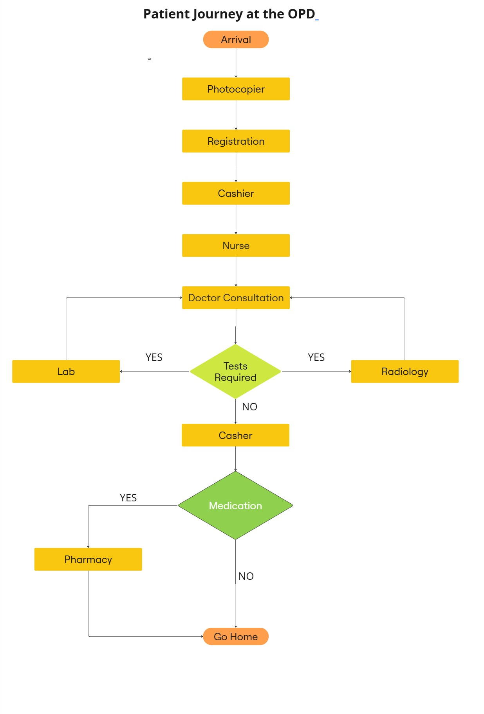

3.3. Study Design
This study employed a cross-sectional observational study design using a time-motion study method to assess the median waiting and process time spent by outpatients at various service delivery points in the hospital.
This study observed waiting times across morning and afternoon shifts for a period of four weeks from 8th May 2025 to 6th June 2025 at the study site, covering potential variations throughout the day and the week.

3.4. Study population and sample
Exclusion: Pregnant women, children under five years of age, and disabled persons were excluded to maintain the study's focus on the typical general outpatient department flow. Pregnant women, young children, and disabled individuals often required or received special accommodations (e.g., expedited services, skip lines) that deviated from the standard patient pathway. Excluding these groups allowed for a more accurate assessment of time-motion patterns for the majority of OPD patients.
Patients attending the specialty outpatient departments, such as Dentistry, Ophthalmology, Surgery, ENT, and Internal Medicine, were not included in this study. These departments are in a separate wing of the hospital and operate with distinct patient flow processes, often structured around scheduled appointments. As such, their inclusion would have introduced a different dynamic not aligned with the general OPD's walk-in model.
Inclusion: The study population consisted of all outpatients attending the general OPD department for consultation or treatment.

3.4. Sampling Strategy
A convenience sampling approach was employed; patients were enrolled based on their arrival during the data collectors’ scheduled observation periods (6:30 AM- 5:00 PM). This approach was chosen because patient arrivals at the OPD are unpredictable, making it the most practical and efficient way to capture a continuous flow of cases without disrupting routine care.
Two data collectors with clinical experience (nurses) participated in data collection. Due to the detailed nature of the observations, each collector was able to follow a maximum of three patients per day. Based on this capacity, approximately 135 observations were expected over the four-week study period.

3.5. Data Collection Procedure
At the OPD entrance, the data collectors observed each selected patient throughout their visit, from registration through consultation until the patient exited the OPD. The data collectors maintained a discreet distance to ensure that patients remained unaware of their presence. They documented each patient's movement through different stages of care and noted the time of entry and exit at each station. No engagement occurred with healthcare providers or other individuals during the observation process.
Data collectors also noted down any observed factors that would contribute to a longer waiting time for the patient.
In addition, information on staffing levels, patient load, and available infrastructure was collected through hospital records and visual inspection. This contextual data was used to support the interpretation of the time-motion observations and to identify systemic contributors to delays.

3.6. Data Collection Tool
The primary data collection tool for this study was a Time-Tracking Observation Worksheet (see Appendix A). The tool was pre-tested on twelve patients during a pilot observation day to ensure clarity, completeness, and feasibility. Minor adjustments were made to improve the layout and observer note sections based on pilot feedback.
This tool enabled the capture of the exact arrival and departure times of patients at each station, along with any relevant observations or incidents that may impact waiting times.
The worksheet was designed to record patient ID, station name, arrival time (when the data collector started following the patient), entrance time at a station, departure time from that station, and observer notes.

3.7. Key Measures
The three key measures of this study include:
- Process time by station: The process time by station is the duration from when a patient begins receiving service at a specific station to when the service is completed at that station.
- Wait time by each station: The wait time at a specific station is the duration from when a patient arrives at the station to when they begin receiving service at that station.
- Overall time spent on the visit: The overall time was the duration from when a patient arrived at the OPD to when they departed the OPD.

3.8. Data collector training
Two data collectors were assigned to this study. Data collectors were trained on the tool, objectives, and expected outcomes. A week before data collection, they toured the OPD to familiarize themselves with the setting and goals.

3.9. Data Management
Data collectors entered all the collected data into Microsoft Excel for initial organization and cleaning. The data was imported into Python for detailed analysis. Data was securely stored in a UGHE OneDrive storage for a period of 10 years.

3.10. Data Analysis
Descriptive statistics were used to summarize the key measures and to highlight the main observations contributing to delays. Waiting time data are often skewed by extreme values (e.g., a few patients with unusually long waits), which can distort the mean. For this reason, the median was used as the primary measure of central tendency, as it better represents the typical waiting experience by reducing the influence of outliers. The interquartile range (IQR) was also reported to show the spread of the middle 50% of values.
Non-parametric tests were used because the waiting time data did not follow a normal distribution. The Kruskal-Wallis test assessed variations in wait times across different days of the week, and the Mann-Whitney U test assessed variation between morning and afternoon shifts.
Observational data recorded throughout the patient's journey were summarized using frequency counts. All analyses were conducted using Python 3.9 (via the Anaconda distribution), using the SciPy and Pandas libraries. A significance level of p < 0.05 was used.

4. RESULTS
Data from 131 outpatients were collected over 4 weeks, from 8th May to 6th June 2025. Of these visits, 13 (10%) occurred in the afternoon, 118 (90%) took place in the morning, 24 (18%) took place on Monday, 28 (21%) on Tuesday, 26 (19.8%) on Wednesday, 35 (26.7%) on Thursday, and 18 (13.7%) on Friday. Among the patients observed, 64 (49%) dropped out after registration and did not proceed to subsequent stations. Among sixty-seven who saw a physician, 23 (34%) required a second consultation during their visit (Table 1).
Table 1. Summary of Process Times by Station
 |  | n (%)
Sample |  | 131
Time of day | Morning Visits (before 12:00 PM) | 118 (90.1%)
Time of day | Afternoon Visits (after 12:00 PM) | 13 (9.9%)
Visit Distribution by Weekday | Monday | 24 (18.3%)
Visit Distribution by Weekday | Tuesday | 28 (21.4%)
Visit Distribution by Weekday | Wednesday | 26 (19.8%)
Visit Distribution by Weekday | Thursday | 35 (26.7%)
Visit Distribution by Weekday | Friday | 18 (13.7%)
Patient types | Non-OP (Dropped Out After Registration) | 64 (48.9%)
Patient types | Patients continued OP services | 67 (51.1%)
OP consultation (n=67) | Required to see a physician once | 44(66%)
OP consultation (n=67) | required to see a physician twice | 23 (34.3%)

Patients spent a median of 264 minutes at the OPD from arrival to exit (total patient journey), with the total median waiting time of 248 minutes. The longest waits were recorded at Radiography (median WT: 118 minutes) and Consultation (First Visit) (93 minutes) stations, while the Laboratory (17 minutes) and Pharmacy (26.5 minutes) had the shortest. The median total process time for a patient receiving care at the OPD was 30 minutes, with Radiography having the longest process time (37 minutes). In contrast, the Photocopier had the shortest process time (2 minutes) (Table 2).
Table 2. Median Wait Times and Process Time by Station
Station | Median wait time (Q1-Q3) | Median process time (Q1-Q3)
Photocopier | 79 (12-95) | 2 (1-3)
Registration | 33 (16 -63) | 5 (4-12)
Cashier (Initial Payment) | 32 (13 -48) | 6 (3-9)
Vitals | 47 (15 -95) | 6 (4-10)
Consultation (First Visit) | 93 (46 -164) | 11 (7-14)
Laboratory | 17 (7-25) | 6 (4-10)
Radiography | 118 (59 -204) | 37 (27 -50)
Consultation (Second Visit) | 66 (42 -130) | 8 (4-15)
Cashier (Final Payment) | 38 (19 -86) | 6 (4-9)
Pharmacy | 26.5 (15 -43) | 5 (3-6)
Total | 248 (91-428) | 30 (11-56)
Overall Time | 264 (106-495)
Q1 = 1st quartile; Q3 = 3rd quartile
There were significant differences in time spent at the OPD based on arrival time. Patients who arrived in the morning (before 12:00 PM) spent a median of 273.5 minutes at the facility, while those who arrived in the afternoon (after 12:00 PM) spent only 40 minutes (p = 0.0031). No statistical significance was associated with wait times across different days of the week (p = 0.4201) (Table 3).
Table 3. Overall Time Spent in hospital by day of the week and time.
 |  | median (Q1-Q3) | P-value
Day of the week | Monday | 415 (123 -653) | 0.4201
Day of the week | Tuesday | 302 (87 -444) | 0.4201
Day of the week | Wednesday | 274 (140 -404) | 0.4201
Day of the week | Thursday | 261 (67 -477) | 0.4201
Day of the week | Friday | 207 (75 -382) | 0.4201
Time of day | AM | 273.5 (107-499) | 0.0031*
Time of day | PM | 40 (12 -122) | 0.0031*
*Significant at P<0.05
Morning and afternoon arrivals were further compared at stations. Two stations showed significant differences in waiting time between morning arrival and afternoon arrival: 1) Photocopier (p <0.0001) and 2) Registration (p = 0.0002). No statistically significant differences were observed at other stations (Table 4).
Table 4. Station Wait Times by Time of Arrival (AM vs PM)
 | Median wait time |  | P-value
Station | AM | PM | P-value
Photocopier | 85 | 2 | <0.0001*
Registration | 38 | 10 | 0.0002*
Vitals | 51 | 23 | 0.5285
Consultation (First Visit) | 93 | 165 | 0.5503
Cashier (Final Payment) | 41 | 5 | 0.1527
Pharmacy | 27 | 12 | 0.1715
*Significant at P<0.05
Observed factors contributed to the long wait time
Multiple issues were observed that contributed to delays across the OPD. The most frequent observation was that patients returned the next day to complete unfinished services (n = 24). Other recurring problems included patients not knowing where to go (n = 16), lack of a clear order or process (n = 13), and staff stepping away or being unavailable during lunch hours (n = 16). Additional factors included network or machine issues (n = 6), patients being overtaken in line (n = 5), inability to pay for services (n = 1), and a power outage (n = 1) (Table 5).
Table 5. Observed events potentially causing delay
Observation | Frequency
Returned after the service was not completed the previous day | 24
Uncertainty about where to go within the facility | 16
No clear order for patients to follow as they wait for care | 13
Staff gone for lunch or stepped away | 16
Network or machine issues | 6
Overtaken in line by other patients | 5
The patient did not have money | 1
Power outage | 1

Specific congestion patterns were noted at certain points in the OPD flow. An average of 29 patients were already present by 6:30 a.m., 1.5 hours before official opening hours (8:00 AM) (Figure 2).
Figure 2. Patients observed waiting at 6:30 AM
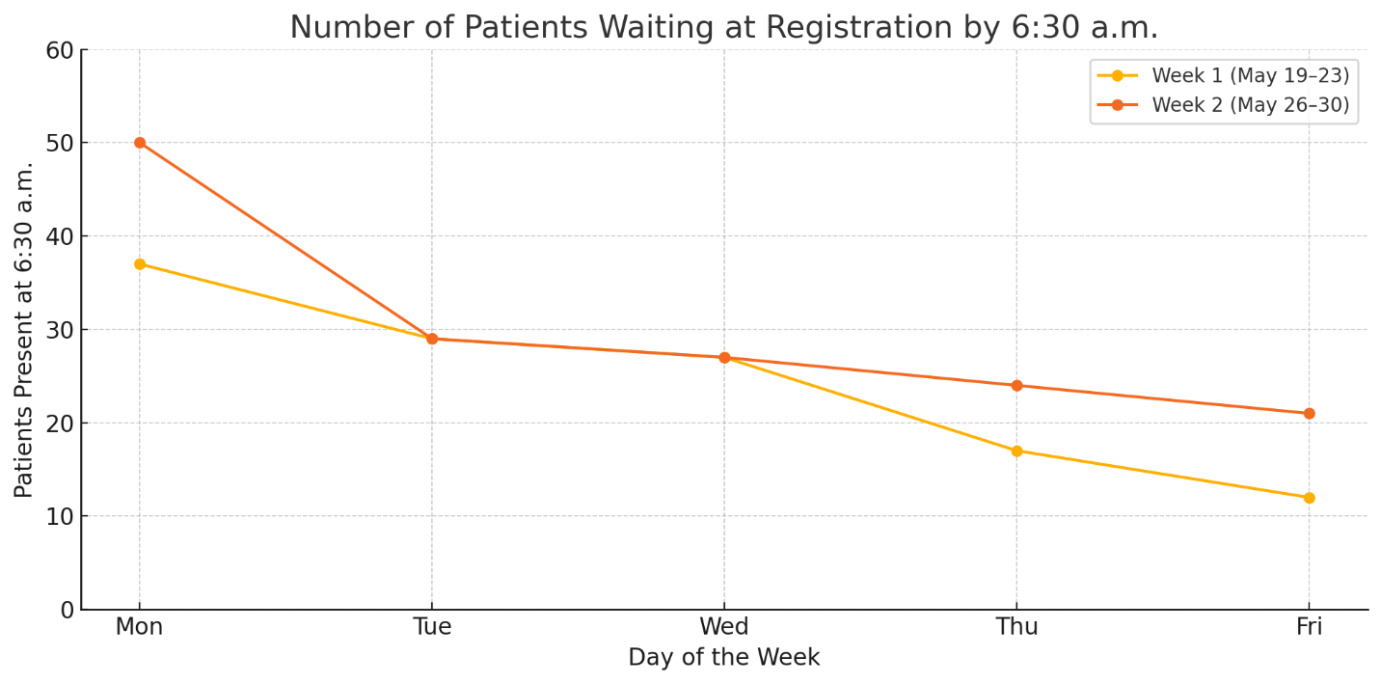

Radiology utilized a computer system to record all the services provided to patients and thus has time-stamped records for all transactions. On average, 72% of all patients referred to for CT scans were sent after 12 PM (Figure 3).
Figure 3. Number of Patients Sent to Radiography Before and After 12 PM
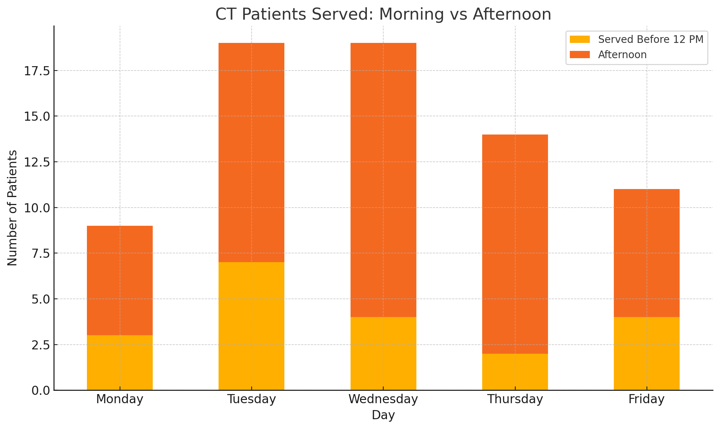
A portion of the patients who registered at the OPD were not there to utilize the OPD services but were instead from the other services, e.g., Emergency, Pediatrics, Oncology Clinics, or inpatients who registered at the OPD but did not continue with the rest of the OPD services. They left the OPD after registration and did not proceed to any other OPD station (drop out). The largest dropout was observed on Wednesday, where only 89 of the 407 (22%) registered patients were utilizing OPD services, with 318 (78%) dropping out (Table 6, Figure 3)
Table 6. Number of Patients Exiting OPD Flow After Registration
Day | Registered | Continued at OPD | Dropouts
Monday | 337 | 121 (36%) | 216 (64%)
Tuesday | 339 | 100 (29%) | 239 (71%)
Wednesday | 407 | 89 (22%) | 318 (78%)
Thursday | 185 | 61 (33%) | 124 (67%)
Friday | 165 | 20 (18%) | 145 (88%)
Total | 1433 | 391 (27%) | 1042 (73%)

Figure 4. Number of Patients Exiting OPD Flow After Registration (by Day of the Week)
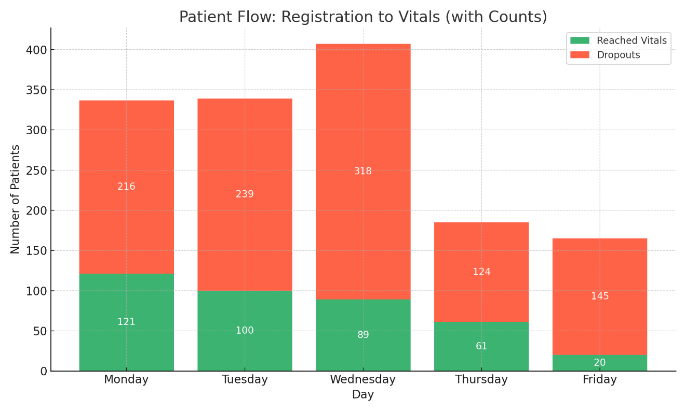
The OPD has an average capacity of 80 consultations per day. Any patients beyond the daily capacity had to return to the OPD the next day (Spill over). In total, there were 121 patients who reached consultation on Monday, but only 80 were seen by physicians. Resulted in 41 patients remaining unseen and spilled over to Tuesday (Table 7, Figure 4).
Table 7. Daily consultation load and carryovers
Day | Patients Reaching Consultation | Doctor Capacity (40 /Doctor) | Unseen Patients | Cumulative Spill over
Monday | 121 | 80 | 41 (33%) | 41
Tuesday | 100 | 80 | 20 (20%) | 61
Wednesday | 89 | 80 | 9 (10%) | 71
Thursday | 61 | 80 | 0 (0%) | 51
Friday | 20 | 80 | 0 (0%) | 0

Figure 5. Daily consultation load and carryovers
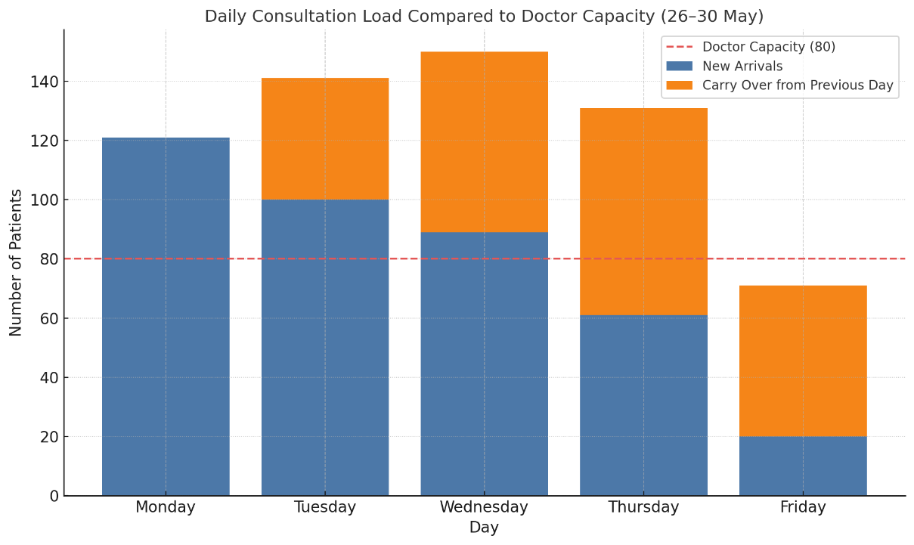

5. Discussion
This study assessed the wait time of 131 outpatients at Butaro District Hospital over a four-week period. Operational inefficiencies were identified, many of which mirror challenges faced in similar low-resource outpatient settings.
The overall outpatient journey, from entry to exit, had a median duration of 264 minutes (IQR: 106-495). The median total wait time per patient across all stations was 248 minutes (IQR: 91-428), substantially exceeding the International Institute of Medicine's global standard of a 30-minute wait time (Bs, 2020). The median total process time was 30 minutes (IQR: 11-56).
A significant difference (P = 0.0031) in total time spent at the OPD was seen between morning arrivals (median: 273.5 minutes) and afternoon arrivals (median: 40 minutes), specifically at the Photocopier (p <0.0001) and Registration (p = 0.0002). These disparities in timing point to broader operational imbalances across the outpatient care pathway. The following section discusses the structural inefficiencies within the hospital system that contributed to these delays.
System-related Inefficiencies.
System-level inefficiencies contributed to prolonged outpatient delays at Butaro District Hospital. A key factor was mixing OPD and non-OPD patient streams at shared entry points, namely the photocopier and registration. Particularly at registration, nearly half (48.9%) of the patients tracked exited the process after registration. Registration data showed an average daily dropout rate of approximately 73%, highlighting significant non-OPD patients coming to the same station. The shared registration created unnecessary front-end congestion, impacting subsequent service stations. This pattern of unfiltered patient intake and shared registration points mirrors challenges observed in a regional study of 22 countries in West and Central Africa selected based on high under five mortalities as a proxy for fragile health systems, which found that 64% of these countries identified shared intake streams as a severe bottleneck to efficient care delivery in hospitals. The study observed that these shared intake streams lead to frontend congestion and strain on outpatient services (Simen-Kapeu et al., 2021).
Another critical issue was the unstructured management of return visits. Among the patients who had already completed an initial consultation, 34.3% returned later the same day, frequently for the purpose of receiving and discussing test results. However, these same-day returnees had to queue again alongside newly arriving patients, even though their needs differed significantly. Often, returning patients spent extended periods waiting in line only to find that their test results were not yet ready or, conversely, required minimal interaction solely to confirm available results. This lack of a separate process for these returnees resulted in unnecessary waiting times, increased congestion in consultation areas, added unnecessary strain on the limited staff, and impeded overall OPD efficiency. Furthermore, in the radiology department, it was observed that they mostly received patients from OPD consultation in the afternoon. These patients were sent there without checking in with available capacity at the radiology to see if these patients could still be served that day or should be advised to come the next day via an appointment. Similar instances of unstructured visits in the OPD can be seen in Tanzania. Kilimanjaro Outpatient Hospital had a median waiting time of six hours due to unscheduled visits and return visits, the implementation of a structured appointment mechanism which included setting designated return times and clear communication of when test results and doctors would be available showed a 45% reduction in overall median waiting time to 3.3 hours, demonstrating that formalizing return visit management can substantially improve patient flow and service efficiency (Mwanswila et al., 2024).
An additional factor contributing to delays was patient arrival patterns. Observations revealed that on average, twenty-nine patients were already waiting at the OPD by 6:30 AM, well before the OPD officially started at 8 AM. This led to long idle waiting periods before services began. The impact of this pattern was evident in the difference in registration wait times: morning arrivals, who waited before services began, experienced significantly longer registration times (median: 37.5 minutes), compared to those who arrived in the afternoon, when services were already ongoing (median: 10 minutes), with P = 0.0002. This early clustering of patients not only inflated perceived waiting times but also created congestion that overwhelmed staff at the start of service.
Staff-related Inefficiencies.
Staffing shortages at critical service points intensified delays. Observational data revealed frequent disruptions due to limited personnel, with just two nurses managing vital signs (both seeing one patient at a time together), two doctors managing consultations, and a single radiologist supported by three technicians and one nurse in radiology (only the radiologist could approve all test results). The limited staffing was particularly problematic at these high-demand stations, consistently creating chokepoints throughout the patient journey. Adding to this limited staff, Observers also recorded 16 instances of staff absences or unavailability during the four-week period. Similar scenarios have been documented in Nigeria, where understaffing at key service points led to substantial delays for the patients. For instance, in the Harcourt Teaching Hospital, 70% of the patients waited for 56 minutes or more before receiving care. Among the factors identified to have contributed to delays, 88% of the patients strongly agreed that staff shortages were the second highest cause of the long waiting times they experienced (Isaruk et al., 2024).
Not only was the OPD understaffed, but all critical service stations observed at Butaro District Hospital ceased operation during lunchtime, typically from 12:30 PM to 2:00 PM. These breaks disrupted patient flow continuity, causing accumulated patient queues that significantly contributed to longer waiting times. It was observed that although OPD services officially opened at 8:00 AM, doctors at consultation began seeing patients around 9:00 AM. A similar pattern was observed in radiology, where imaging services began an hour after OPD operations commenced. Our findings align with a study conducted at Gahini Hospital, where consultation services started as late as 10:00 AM, and 60% of OPD stations closed during lunch, both factors were identified as contributing to an overall average waiting time of six hours and 40 minutes (Rutaremara, 2019). These late start times delayed patient processing and contributed to early crowding and delays across the system.
These staffing inefficiencies became more dangerous as we observed a clear mismatch between healthcare demand and system (staff) capacity. In our study, daily OPD patient volumes surpassed the service capacity of 80 patients, leading to an accumulation of unseen patients from 41 on Monday to 71 by Wednesday, creating a scenario where each day had to first take care of patients from the previous day before attending to the new ones, further adding to delays on the newcomers. Our observations confirmed this spillover effect; 24 of the patients followed stayed over to complete their care on the next day. A similar trend where a demand to capacity mismatch creates spillovers to the next day and adds to delays was observed in a U.S based academic emergency department, a daily excess of 27.71 patients beyond provider capacity led to ques that often extended into the next day adding to the delay and clogging the patient flow of the next day (Stenson et al., 2021).
Navigational Inefficiencies
The absence of clear patient guidance and inadequate signage significantly prolonged patient journeys. Observers noted 16 instances where patients appeared uncertain of their next steps, contributing to idle time and additional congestion. Additionally, 13 instances were recorded where patients waited idly at a station due to a lack of clear guidance; these patients would be at the wrong stations or wait on the sidelines. Within this confusion at the OPD, we identified five cases where patients were overtaken by others or inadvertently skipped due to the absence of a structured queueing system or clear direction to follow. All this confusion and hardship in navigating the facility were observed to contribute to longer waiting times.
The most likely suspect of all this confusion was the hospital's lack of a centralized help desk or visible signage or map, forcing patients who were mostly new to the facility to navigate it on their own. Similar findings from a U.S. study comparing two hospitals, one with and one without a patient navigation team, showed that patients in the hospital without navigation experienced significantly longer delays in their journeys than their counterparts (p = 0.0001) (Ohlstein et al., 2019).
Recommendations
Based on the findings of this study, the following recommendations are proposed to address operational inefficiencies and enhance the overall patient experience. These recommendations aim to address the identified challenges through a systems approach, enhanced staff management, environmental modifications, and quality improvement measures.
System Improvements
Establish dedicated registration and photocopier stations/queues for specific patient streams such as Urgency, Inpatient, Pediatrics, and Oncology.
Currently, mixing OPD and non-OPD patients at a single registration point creates significant bottlenecks, as nearly half of the patients exit immediately after registration, causing congestion at the beginning of the patient journey for the OPD patients. Segregating patient streams by creating dedicated registration stations or separate queuing lines for specialty OPD, inpatient, pediatrics, General OPD, oncology, and other departments would streamline intake at the OPD, minimize unnecessary queuing, and enable staff to manage flow more efficiently. This strategy would align with the Rwanda Hospital Accreditation Standards, which emphasize the importance of efficient admission and registration processes, including clear and distinct patient pathways to optimize service delivery and reduce congestion (Ministry of Health Rwanda, 2022).
Implementing this solution throughout Butaro Hospital would align with these standards, enhance patient flow, reduce waiting times, and improve patient satisfaction and quality of care.

Implement a numbered seating system at service stations to maintain orderly queues and reduce confusion.
Patients often become uncertain about their place in line in the absence of structured queuing, leading mto skipped turns and waiting idly. Numbered seating would assign patients specific seats sequentially, preserving queue integrity and minimizing disputes. This method was recommended in similar settings, such as in the case of Tanzania, Dodoma, where the Ministry of Health audited 12 health facilities and observed patients being overtaken in line, lacking a clear order to follow. They suggested numbered chairs as a low-cost intervention to promote fairness and order (Mwanswila et al., 2024). Implementing such a system at Butaro Hospital would help manage patient flow more transparently and efficiently, improving the overall patient experience.
Introduce a structured return visit scheduling system using appointment slips for follow-up consultations.
The study found that over one-third of patients who visited the consultation returned the same day for test result discussions without formal scheduling, causing repeated queuing alongside new arrivals. This lack of prioritization increased congestion and strained limited staff capacity. Formalizing return visits with appointment slips, such as numbered papers paired with informed check-ins to the labs, to know when the results will be available. This would allow the hospital to triage and prioritize these return patients, reduce unnecessary waiting, and improve patient flow.
A similar intervention was implemented at Aravind Eye Hospital in India, where returning patients and high walk-in volumes led to overcrowding and repeat queuing. To manage this, the hospital implemented a real-time scheduling system that checked doctor availability and the status of test results from previous stations, then directed each patient to a specific room at a set time. This reduced unnecessary waiting and repeat queues, cutting average wait times by over 26%, without needing extra staff (Munavalli et al., 2019).
Staff Management
Align staffing allocations with observed patient volumes, particularly increasing staff on high-demand days such as Mondays and Tuesdays.
This study identified critical staffing shortages at key service points, with only 2 nurses working in vitals and 2 doctors for consultations to manage the high patient volumes at the OPD, which contributed to bottlenecks and delays. Adjusting staff allocation by adding a third vitals nurse and consultation doctor to match peak patient arrivals, especially in the mornings and during the first days of the week, could optimize hospital capacity and reduce waiting times. Similar strategies have been suggested elsewhere, for instance, a time-motion study in Nigeria observed long idle periods among staff during low patient volume hours and recommended realigning schedules and increasing staff at peak times to match patient volumes, a strategy similar to what is being proposed here (Uzochukwu et al., 2024).
In addition, a study aimed at reducing emergency department waiting times applied shift allocation in five hospitals, aligning the staff with peak patient volume hours and days, reducing waiting times by up to 45% (Sinreich et al., 2012). These two initiatives show that if we proactively manage and allocate staffing levels to meet patient demand when it is high, Butaro Hospital can reduce operational strain and enhance the overall quality of care.

Implement staggered lunch breaks to ensure the continuous operation of vital services.
Observations revealed that critical service stations ceased operation during lunch hours, causing patient queues to accumulate and prolong overall wait times. Staggering breaks or shifts among staff would ensure essential services remain operational throughout the day, which would prevent service interruptions and smoothen patient flow.
A study in China evaluated a staffing model in a hospital where two six-hour shifts were used, with a one-hour overlap between them. This overlap ensured that there was always at least one nurse present in the ward, preventing gaps in coverage during shift changes. As a result, the wards were always staffed, and 86.6% of nurses reported improved teamwork and greater satisfaction with this new way of working, compared to traditional non-overlapping shifts that would close until the new nurse came in (Huang et al., 2021). Adopting the practice of always having one staff member in the rooms would maximize effective working hours and enhance the overall patient experience.
Navigation Enhancements
Permanently station a customer service team at the OPD entrance to assist with patient navigation and orderly movement.
The absence of clear guidance and navigation support was a significant cause of patient confusion and idle waiting, as patients struggled to identify their next steps. A dedicated customer service or patient navigation team at the entrance can provide real-time assistance, direct patients appropriately, and maintain orderly queues. A 2017 study at an outpatient diabetics clinic found that a navigation program in their hospital increased clinic visits by 6.4% per year and reduced no show rates and dropping out of the patient journey by 10% implying that patient navigation can improve patient satisfaction, reduced confusion, and enhanced access to care across diverse healthcare settings (Horný et al, 2017). Implementing such a team at Butaro Hospital would help mitigate environmental inefficiencies and enhance the overall patient experience.
Install clear, multilingual signage and visible patient flow charts at key decision points, particularly at registration.
Inadequate signage contributed significantly to patient disorientation and inefficient movement through hospital spaces. Providing clear, culturally, and linguistically appropriate signs and flow charts, including pictorial signboards, could help patients understand the process, reduce idle time, and prevent waiting in the wrong queues. A study conducted in a dental hospital in India, after putting in place pictures and maps in their local languages to ease navigation of the hospital, found that 97.3% of the patients agreed that these pictures improved their ability to identify the right departments to go to (Malhotra et al., 2016). Implementing similar signage solutions at Butaro Hospital would address key environmental barriers to efficient outpatient flow and enhance the overall patient experience.

Limitations
While this study offered critical insights into outpatient delays at Butaro District Hospital, it is essential to acknowledge several limitations faced during the research process.
Time-Bound and Context-Limited Observations: We collected data over a single four-week period. As such, potential fluctuations due to seasonal trends, staffing rotations, or external policy changes may not have been captured, limiting the generalizability of findings across time.
Scope of Patient Population: The study excluded certain groups, including pregnant women, young children, patients with disabilities, and individuals accessing specialty departments. As a result, the findings reflect only the experiences of general outpatient encounters and may not apply to all hospital users.
Observation-Only Design: The research relied exclusively on non-intrusive, distance-based observation to minimize disruptions. While necessary for discretion, this approach limited access to nuanced patient-provider interactions and missed opportunities to explore staff perspectives or systemic motivations behind delays.
Limited Observation Hours: Observations were conducted only between 6:30 a.m. and 5:00 p.m., potentially missing key workflow patterns occurring outside these hours.

6. Conclusion
This study of 131 outpatients at Butaro District Hospital over four weeks highlighted the significant operational and systemic barriers to efficient care in rural Rwandan settings. Patients experienced a median total journey time of 4 hours 24 minutes, with over four hours spent on waiting, far exceeding the 30-minute international benchmark for outpatient care. We identified longer delays if patients arrived in the morning than when they arrived in the afternoon. Early-morning congestion was common, as an average of twenty-nine patients were already waiting by 6:30 am, resulting in prolonged idle periods and overwhelming staff at the start of service at 8 am. The shared entry points for OPD and non-OPD streams created unnecessary congestion and inefficiency at the beginning of the patient journey. Furthermore, 34.3% of patients who completed consultations returned for a second consultation the same day, yet lacked prioritization or formal scheduling, contributing to additional queuing and resource strain.
Staffing shortages, absence, or unavailability during lunch break were observed to contribute to the delays. Additionally, the patient volume frequently exceeded the daily consultation capacity, resulting in patients staying until the next day. Inadequate signage, lack of a clear queuing system, and absence of a help desk or formal navigation assistance were observed to contribute to instances where patients lost their place in line or got in the wrong cue.
In response to these findings, targeted, evidence-based interventions are recommended. Introducing structured queuing through numbered chairs, aligning staff schedules with peak patient arrival, and issuing appointment slips could help reduce congestion and minimize unnecessary re-queuing. Dedicating a customer service team at the OPD entrance and providing clear, multilingual signage and patient flow charts would enhance patient navigation and experience.
This study offers robust, actionable insights into the drivers of long waiting times at Butaro District Hospital. By implementing the recommended interventions, the hospital can significantly reduce delays, improve patient experience, and serve as a model for operational improvement in rural healthcare settings across Rwanda and beyond.

7. References
Ab, A., & Kn, K. (2017). An assessment of patient waiting and consultation time in a primary healthcare clinic. 12(1).
Aeenparast, A., Farzadi, F., Maftoon, F., & Yahyazadeh, H. (2019). Patient Flow Analysis in General Hospitals: How Clinical Disciplines Affect Outpatient Wait Times. Hospital Practices and Research, 4(4), 128–133. https://doi.org/10.15171/hpr.2019.26
Alhur, A., Alhur, A., Almunajjim, M. H., Alfaifi, N. M., Ageeli, L. M., Mohammed, A. A., & Alyami, K. H. (2022). A COMPREHENSIVE REVIEW OF HEALTHCARE QUALITY. European Chemical Bulletin. https://doi.org/10.53555/ecb.v11:i9.17773
Augustin, M. (n.d.). IMPROVING PATIENT SATISFACTION RATE THROUGH THE REDUCTION OF WAITING TIME IN OPD SERVICES AT INKURUNZIZA ORTHOPEDIC SPECIALIZED HOSPITAL.
Biya, M., Gezahagn, M., Birhanu, B., Yitbarek, K., Getachew, N., & Beyene, W. (2022). Waiting time and its associated factors in patients presenting to outpatient departments at Public Hospitals of Jimma Zone, Southwest Ethiopia. BMC Health Services Research, 22(1), 107. https://doi.org/10.1186/s12913-022-07502-8
Bs, E. (2020). Timespan at a Specialized Outpatient Clinic of the National Referral Hospital, Uganda. 11(1).
Egbujie, B. A., Grimwood, A., Mothibi-Wabafor, E. C., Fatti, G., Tshabalala, A. M. E. T., Allie, S., Vilakazi, G., & Oyebanji, O. (2018). Impact of ‘Ideal Clinic’ implementation on patient waiting time in primary healthcare clinics in KwaZulu-Natal Province, South Africa: A before-and-after evaluation. South African Medical Journal, 108(4), 311. https://doi.org/10.7196/SAMJ.2017.v108i4.12583
Enabulele. (2018). Patient Waiting and Consultation Time in the General Practice Clinic of the University of Benin Teaching Hospital, Edo State, Nigeria.
Gerard. (2018). QUEUEING THEORY. https://diposit.ub.edu/dspace/bitstream/2445/127366/3/memoria.pdf
Guttmann, A., Schull, M. J., Vermeulen, M. J., & Stukel, T. A. (2011). Association between waiting times and short term mortality and hospital admission after departure from emergency department: Population based cohort study from Ontario, Canada. BMJ, 342(jun01 1), d2983–d2983. https://doi.org/10.1136/bmj.d2983
Horný et al. (2017). Patient navigation to improve diabetes outpatient care at a safety-net hospital: A retrospective cohort study. https://pubmed.ncbi.nlm.nih.gov/29162073/
Huang et al. (2021). The Effect of Staggered Shift Scheduling Mode on Nurses in the COVID-19 Isolation Ward- A Cross Sectional Study. https://pubmed.ncbi.nlm.nih.gov/33682512/
Isaruk et al. (2024). Assessment of Patients’ Waiting Times and Healthcare Delivery at the University of Port Harcourt Teaching Hospital (UPTH), Rivers State, Nigeria. 2024. https://journals.directresearchpublisher.org/index.php/drjphet/article/view/287
Johannessen, K. A., & Alexandersen, N. (2018). Improving accessibility for outpatients in specialist clinics: Reducing long waiting times and waiting lists with a simple analytic approach. BMC Health Services Research, 18(1), 827. https://doi.org/10.1186/s12913-018-3635-3
Karthikeyan, S., Rajan, T. P., Shanu, J. E. J., & Pandi, S. (2024). The time motion study of an out-patient department in a tertiary care hospital in Tamil Nadu. International Journal Of Community Medicine And Public Health, 11(7), 2729–2737. https://doi.org/10.18203/2394-6040.ijcmph20241831
Ku, S., Liu, M., Rea, S., Mulumba, K., Chen, A., Dutta, R., Kakusa, B., Caceres, W., Singh, B., Charon, M., & Montacute, T. (2020). A Tale of Two Sister Clinics: Comparing the Use of Online Scheduling Tools to Reduce Patient Wait Times. Journal of Student-Run Clinics, 6(1). https://doi.org/10.59586/jsrc.v6i1.168
Kwong, T. (2016). Patient Access: Improving Wait Times in a Specialty Clinic. The Health Care Manager, 35(1), 72–79. https://doi.org/10.1097/HCM.0000000000000098
Lederman, R. (2002). Why are we waiting? How poor information systems increase hospital queues. Health Informatics Journal, 8(3), 147–152. https://doi.org/10.1177/146045820200800304
Makua, S. R., & Khunou, S. (2022). Nurse managers’ views regarding patients’ long waiting time at community health centers in Gauteng Province, South Africa. Belitung Nursing Journal, 8(4), 325–332. https://doi.org/10.33546/bnj.2096
Malhotra et al. (2016). Effectiveness of pictorial sign boards for patient navigation in multidisciplinary Dental Facilities. https://www.scielo.org.za/scielo.php?script=sci_arttext&pid=S0011-85162015000200006
Marutha, N. S., & Ngoepe, M. (2017). The role of medical records in the provision of public healthcare services in the Limpopo province of South Africa. SA Journal of Information Management, 19(1). https://doi.org/10.4102/sajim.v19i1.873
McIntyre, D., & Chow, C. K. (2020). Waiting Time as an Indicator for Health Services Under Strain: A Narrative Review. INQUIRY: The Journal of Health Care Organization, Provision, and Financing, 57, 0046958020910305. https://doi.org/10.1177/0046958020910305
Ministry of Health Rwanda. (2022). Rwanda Hospital Accreditation Standards.
Mohebbifar, R., Hasanpoor, E., Mohseni, M., Sokhanvar, M., Khosravizadeh, O., & Mousavi Isfahani, H. (2013). Outpatient Waiting Time in Health Services and Teaching Hospitals: A Case Study in Iran. Global Journal of Health Science, 6(1), p172. https://doi.org/10.5539/gjhs.v6n1p172
Msengwa, A. S., Rashidi, J., & Mniachi, R. A. (2020). Waiting time and Resource Allocation for Out-patient Department: A case of Mwananyamala Hospital in Dar es Salaam, Tanzania. Tanzania Journal for Population Studies and Development, 27(1), 64–81. https://doi.org/10.56279/tjpsd.v27i1.106
Mtonga, K., Gatera, A., Jayavel, K., Nyirenda, M., & Kumaran, S. (2022). Adaptive Staff Scheduling at Outpatient Department of Ntaja Health Center in Malawi—A Queuing Theory Application. Journal of Public Health Research, 11(2), jphr.2021.2347. https://doi.org/10.4081/jphr.2021.2347
Munavalli et al. (2019). Integral patient scheduling in outpatient clinics under demand uncertainty to minimize patient waiting times. https://pubmed.ncbi.nlm.nih.gov/30848693/
Mwanswila, M. J., Mollel, H. A., & Mushi, L. D. (2024). Outcome evaluation of technical strategies on reduction of patient waiting time in the outpatient department at Kilimanjaro Christian Medical Centre—Northern Tanzania. BMC Health Services Research, 24(1), 785. https://doi.org/10.1186/s12913-024-11231-5
Ohlstein et al. (2019). Improved Timeliness of Care for the Underserved: A Potential for Patient Navigation. https://clinmedjournals.org/articles/jor/journal-of-otolaryngology-and-rhinology-jor-5-053.php?jid=jor
Pincus, D., Ravi, B., Wasserstein, D., Huang, A., Paterson, J. M., Nathens, A. B., Kreder, H. J., Jenkinson, R. J., & Wodchis, W. P. (2017). Association Between Wait Time and 30-Day Mortality in Adults Undergoing Hip Fracture Surgery. JAMA, 318(20), 1994. https://doi.org/10.1001/jama.2017.17606
QUEUEING THEORY. (n.d.).
Rutaremara, F. (2019). Reducing long waiting time at outpatients department of gahini district hospital. https://dr.ur.ac.rw/handle/123456789/1874?show=full
Sharma, Sharma, Dr. S. K., & Chowhan, Dr. S. S. (2012). Patient Waiting Time: It’s Impact on Hospital Outpatient Department. International Journal of Scientific Research, 2(3), 253–254. https://doi.org/10.15373/22778179/MAR2013/79
Shisundi, P. Y., Ochanda, D. A., & Nyangena, E. (2023). Factors Influencing Patient Waiting Time in Emergency Department of Khunyangu Sub-County Hospital, Busia Kenya. Bayero Journal of Nursing and Health Care, 5(1), 1096–1107. https://doi.org/10.4314/bjnhc.v5i1.17
Simen-Kapeu et al. (2021). Galvanizing Action on Primary Health Care: Analyzing Bottlenecks and Strategies to Strengthen Community Health Systems inWest and Central Africa. https://pubmed.ncbi.nlm.nih.gov/33727320/
Sinreich et al. (2012). Reducing Emergency Department Waiting Times by Adjusting Work Shifts Considering Patient Visits to Multiple Care Providers. https://www.researchgate.net/publication/254307984_Reducing_emergency_department_waiting_times_by_adjusting_work_shifts_considering_patient_visits_to_multiple_care_providers
Stenson et al. (2021). Understanding Demand and Capacity Mismatch in an Academic Emergency Department Using a Staircase Model of Provider Capacity and Staggered Shift Start Times. https://www.sciencedirect.com/science/article/pii/S0736467921003140
Usman, S. O., Olowoyeye, E., Adegbamigbe, O. J., Olubayo, G. P., Ibijola, A. A., Tijani, A. B., Usman, I. N., Fatunmbi, O. J., Omisakin, T. C., & Ipinmoye, T. (2020). Patient Waiting Time: Gaps And Determinants Of Patients Waiting Time In Hospitals In Our Communities To Receive Quality Services. European Journal of Medical and Health Sciences, 2(1). https://doi.org/10.24018/ejmed.2020.2.1.136
Waiting time and Resource Allocation for Out-patient Department: A case of Mwananyamala Hospital in Dar es Salaam, Tanzania. (n.d.).
Woodworth, L., & Holmes, J. F. (2020). JUST A MINUTE: THE EFFECT OF EMERGENCY DEPARTMENT WAIT TIME ON THE COST OF CARE. Economic Inquiry, 58(2), 698–716. https://doi.org/10.1111/ecin.12849
World Health Organization, World Bank Group, & OECD. (2018). Delivering Quality Health Services: A Global Imperative for Universal Health Coverage. Geneva: World Health Organization. https://doi.org/10.1596/978-92-4-151390-6

8.Appendices

Appendix A
Time-Tracking Observation Worksheet
Date:
ID:
Specialty:
Station | Arrival Time | Departure Time | Remarks
Photocopier
Registration
Cashier
Vitals Check
Consultation
Lab Test
Consultation (Results Review)
Cashier (Initial Payment)
Pharmacy

Appendix B

IMPLEMENTATION PLAN

Task | Responsible person | February |  |  |  | Mar |  |  |  | Apr |  |  |  | May |  |  |  | June |  |  |  | July
Finalizing and submitting IRB proposal | PI
Proposal pitch to faculty (March 18-20) | PI
IRB approval process (6 weeks) | IRB
Approval from Butaro L2TH (2 weeks) | PI
Data collection (3 weeks) | Data Collectors
Data analysis (1 weeks) | PI
Manuscript finalization (4 weeks) | PI
Submission of final capstone (July 1st) | PI
Capstone defense (July 22-24) | PI

Appendix C
PROJECT DISSEMINATION PLAN
The study findings will be disseminated through multiple channels to ensure accessibility to both academic and operational stakeholders. Upon completion of the study, the final report will be archived in the UGHE library and shared electronically with Butaro Level II Teaching Hospital management. Stakeholder meetings will be organized with hospital leadership to discuss actionable recommendations for reducing OPD waiting times and improving overall patient flow.
ETHICAL PROTECTIONS PLAN
This study did not involve interactions with vulnerable populations, as they were excluded. Given its observational nature, no risk was posed to patients, and no medical or psychosocial support was provided. Since no confidential data were collected and the observation did not interfere with patient care, individual patients were not informed. No personal identifiers or sensitive information were recorded, and access to all data was restricted to the research team and stored securely on password-protected devices. Data were securely stored in electronic formats and cloud storage, accessible only to authorized team members. In compliance with UGHE IRB guidelines, data were designated to be retained for 10 years before being securely destroyed, with any physical records securely locked away for the same duration.

